**DESIGN AND SIMULATION ANALYSIS OF SMART BLIND STICK USING ARDUINO NANO**

*Amolina Mohanty, Snehanjali Dash, Jyotirmayee Sahu, Jyotirmayee Panigrahi*

*B. Tech students Dept. of ECE, GIET University, Gunupur, Rayagada, Odisha*

***Abstract -***

The "Smart Blind Stick," an assistive device powered by the Arduino Nano microcontroller, represents a ground breaking advancement in aiding individuals with visual impairments. This innovative technology-driven solution is designed to enhance the mobility and safety of those navigating a world predominantly designed for the sighted. Visual impairment can present significant challenges to daily life. The Smart Blind Stick is engineered to empower individuals with visual impairments, facilitating greater independence and enhanced safety. At the heart of this device is the Arduino Nano, offering a compact yet versatile platform for processing sensor data. This document provides an in-depth exploration of the Smart Blind Stick, focusing on its design, sensor integration, and operational principles. It underscores how Arduino Nano technology drives this innovative solution, with the potential to significantly improve the quality of life for those with visual impairments, enabling safe, independent navigation in a world predominantly visual.

*Keywords –* Arduino Nano, sensor, audio signals, voltage regulator (7805)

**INTRODUCTION**

 The "Smart Blind Stick" attempts to make visually impaired people's life better by increasing their safety and mobility. This assistive device, built around the versatile Arduino Nano platform, combines sensor technology with real-time feedback to provide a comprehensive solution for those with visual impairments. This project integrates cutting-edge sensors, microcontrollers, and communication modules to create a device that not only detects obstacles but also provides real-time feedback to the user. The smart blind stick utilizes ultrasonic sensors [1][2] to detect objects in the user's path and employs haptic feedback or auditory signals to convey information about the surroundings. *Arduino Nano as the Core:* At the heart of this device is the Arduino Nano microcontroller [3], known for its compact size and powerful capabilities. It interfaces seamlessly with a range of sensors to detect obstacles, irregularities in the terrain, or even the proximity to other objects or individuals. *Real - time Feedback:* The device offers real-time feedback through a combination of audible alerts and haptic feedback. Vibrations and sound signals guide the user, alerting them to obstacles or hazards in their path. This feedback system ensures enhanced awareness and safety**.** *Enhanced Mobility:* By providing a "virtual vision" of the surroundings, the Smart Blind Stick empowers users to confidently navigate unfamiliar terrain, avoid obstacles, and maintain their freedom of movement. The simulation analysis plays a crucial role in refining the design and optimizing the performance of the smart blind stick. Through simulations, we can assess various scenarios, environmental conditions, and potential challenges faced by visually impaired users. This iterative process allows us to fine-tune the technology for maximum reliability and usability. By combining hardware innovation with simulation-driven refinement, this project seeks to improve the quality of life for individuals with visual impairments, empowering them to navigate their surroundings with increased confidence and safety.

**LITERATURE SURVEY**

The literature surrounding the Smart Blind Stick, equipped with the Arduino Nano microcontroller, demonstrates the profound impact of assistive technology on the lives of individuals with visual impairments. This literature review synthesizes existing research, highlighting key advancements in the field and underscoring the critical role of this device in enhancing mobility and safety. Innovative Sensor Integration [4]: Studies have consistently underlined the significance of integrating advanced sensors, including ultrasonic and infrared sensors, in the Smart Blind Stick. These sensors enable real-time obstacle detection and environmental perception, providing a heightened sense of awareness to users [5]. Arduino Nano Empowerment: The utilization of Arduino Nano as the core microcontroller has proven instrumental in providing a compact yet robust platform for processing sensor data and enabling real-time feedback mechanisms [6]. Environmental Adaptability: Researchers have emphasized the device's adaptability to changing environmental conditions, including variations in lighting, terrain, and weather. This adaptability ensures the Smart Blind Stick's reliability across diverse scenarios [7]. User-Centric Design: A user-centric approach has been a recurring theme, ensuring that the device's design and feedback mechanisms cater to user preferences and usability [8]. It is made up of a foldable stick with two infrared light detectors attached to it. It is connected to an earpiece so that the blind can be warned of detected obstacles through speech alerts, Infrared Sensor types [9]. Alternatively, gadgets that use ultrasonic sensors like K sonar might protect him from challenges rather than guiding him [10]. These innovations give the blind the assistance they need to move around in unfamiliar environments, which increases their confidence and ensures their safety. Various visual tools have been developed. [11],[12].

*Motivation behind this project*

The motivation behind creating a "Blind Stick using Arduino Nano" project is to provide assistance and enhance the independence of visually impaired individuals. This innovative project aims to use technology to help blind individuals navigate their surroundings more safely and confidently by detecting obstacles or objects in their path. By utilizing an Arduino Nano, sensors, and other components, this project can offer real-time feedback and alerts to the user, thereby improving their mobility and reducing the risk of accidents. It's a practical application of technology to address a specific need in the visually impaired community.

**DESIGN AND SIMULATION**

We have used Proteus 8.13 for our circuit simulation, and have completed this circuit by using Arduino Nano, Ultrasonic Sensor, LDR, Modulo Rx, Modulo Tx [13]. For generating hex code for Arduino Nano, Arduino IDE software [14] is used. It has a remote controller which has a push button for taking input and the battery and Modulo Tx is used.

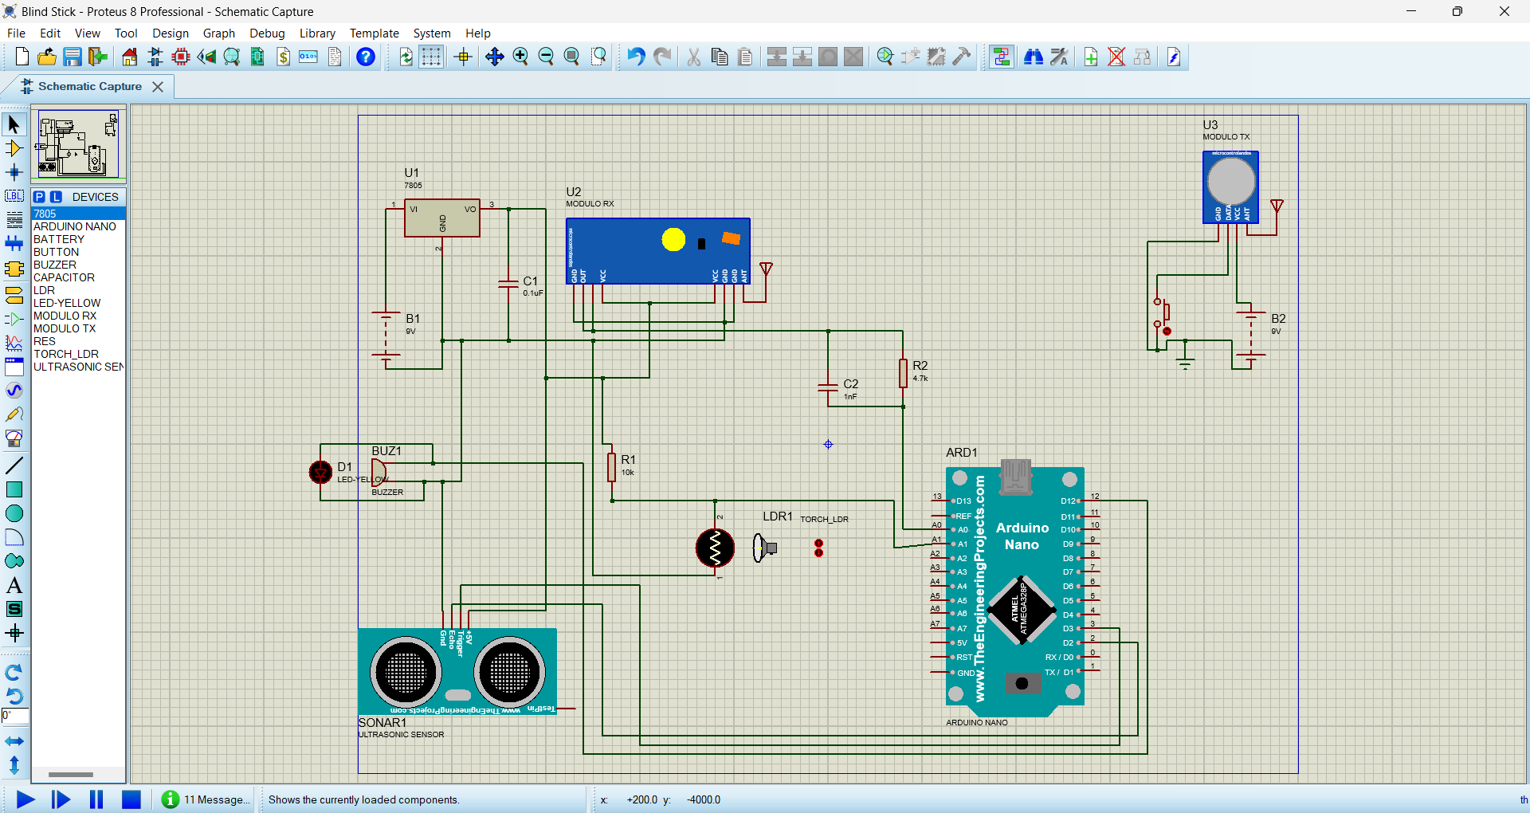

**Fig 1:** Circuit Design of Smart blind stick using Proteus

**Components Required**

Here, 7805 voltage regulator is used, that provides +5 volts power supply. This Arduino Nano has 8 analog pins and has 6 PWM pins among the digital pins. It comes with 16 MHz clock speed via a crystal oscillator, its operating voltage varies from 5v to 12 v. A battery of 7 to 12 volts is used and a buzzer is used to provide auditory alerts and feedback. Additionally, resistor, capacitor, LDR [15] and ultrasonic sensor (HC-SR04) is also applied for circuit stability and operation. This Ultrasonic Sensor consists of a

transmitter and receiver. The sensor will measure how far things are without touching them, and it uses sound waves to get the measurements right. It works very well when things are 2 to 4 cm away.

**BLOCK DIAGRAM**

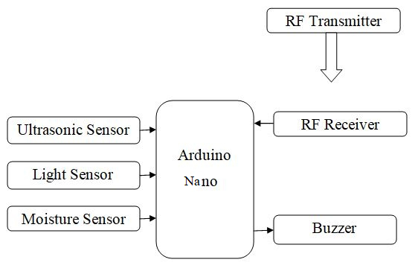

**Fig 2:** Block Diagram of circuit

**SIMULATION PARAMETER**

|  |  |  |  |
| --- | --- | --- | --- |
| **SL NO.** | **COMPONENTS** | **TYPE** | **RANGE** |
| 1. | Voltage regulator | 7805 | 1no. |
| 2. | Arduino nano |  | 1no. |
| 3. | Battery | 9 V | 2nos. |
| 4. | Buzzer |  | 1nos. |
| 5. | Capacitor | Capacitor | (2nos.)  0.1uF(1no.)  1nF(1no.) |
| 6. | LDR | 24.0 | 1no. |
| 7. | LED-yellow |  | 1no. |
| 8. | Resistor |  | (2nos.)  4.7k(1no.)  10k(1no.) |
| 9. | Ultrasonic sensor | HC-SR04 | 1no. |

**RESULT ANALYSIS**

The result analysis of the "Smart Blind Stick" circuit involves assessing its performance and functionality. It can detect obstacle by determining the blind stick’s ultrasonic sensors and can analyse the obstacle over a range of distances. It can evaluate between sensors range and sensitivity to identify a variety of obstructions, at various angles. From Fig 3: , the sensor is observed, when no obstacles are found nearby (which means the Buzzer doesn’t give any audio signals and for this proteus circuit, the LED is off or say doesn’t glow). Now, in Fig 4., the Proteus circuit shows the sensor when any obstacle is found (Buzzer gives auditory signals and for this proteus circuit, the LED bulb glows).

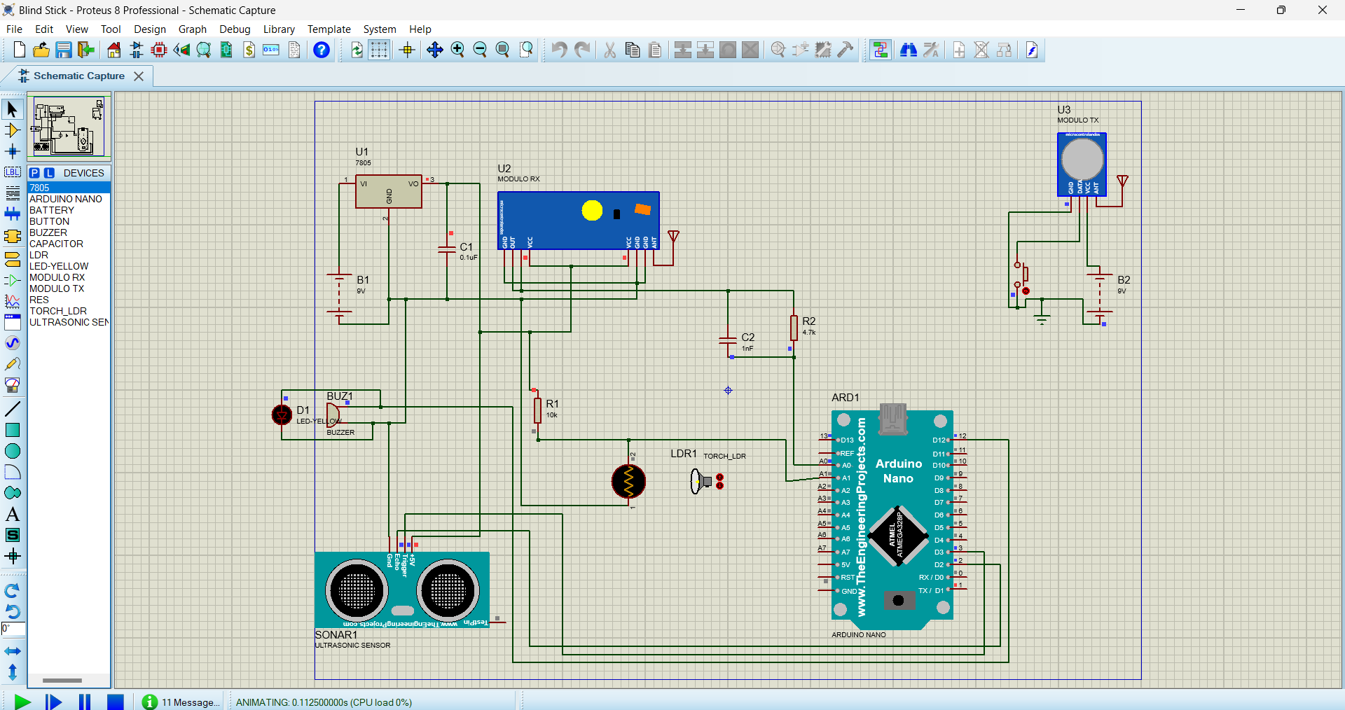

**Fig 3:** *Sensor when any obstacle is not found*

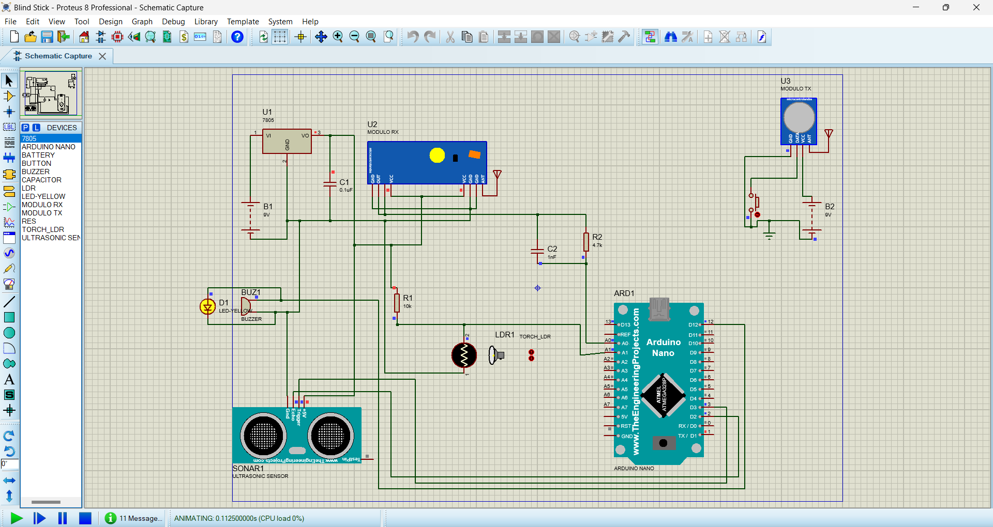**Fig 4:** *Sensor when any obstacle is found*

**CONCLUSION**

The Smart Blind Stick with Arduino Nano serves as an example of how technology has the potential to significantly improve the lives of people who have visual impairments. It represents inclusivity and advancement by providing improved mobility, independence, and safety. We are paving the way for a more inclusive, accessible, and equitable future for all as we continue to innovate and improve this assistive technology. A demonstration of how technological advancement can improve the lives of people with visual impairments is the Smart Blind Stick, which is powered by the Arduino Nano microcontroller. With real-time feedback, obstacle detection, and environmental adaptability, this assistive device has become an influential partner in the attempt for increased mobility and safety. The conclusions highlight its transformational role and its ongoing promise to help the blind.

**REFERENCE**

[1] Arun Francis, G., Arulselvan, M., Elang kumaran, P., Keerthi Varman, S., & Vijaya Kumar, J. (2020). Object detection using ultrasonic sensor. Int. J. Innov. Technol. Explor. Eng, 8, 207-209.

[2] Latha, N. A., Murthy, B. R., & Kumar, K. B. (2016). Distance sensing with ultrasonic sensor and Arduino. International Journal of Advance Research, Ideas and Innovations in Technology, 2(5), 1-5.

[3] Ismailov, A. S., & Jo’Rayev, Z. B. (2022). Study of Arduino microcontroller board. Science and Education, 3(3), 172-179.

[4] Mitiche, A., & Aggarwal, J. K. (1986). Multiple sensor integration/fusion through image processing: a review. Optical engineering, 25(3), 380-386.

[5] Ghosh, S., Das, P., & Bhattacharya, S. (2019). "A Novel Smart Blind Stick for Visually Impaired People." In Proceedings of the 4th International Conference on Electrical, Computer and Communication Technologies (ICECCT), Coimbatore, India.

[6] Hossain, M., Paul, S., Mahmud, M. H., & Hasan, M. (2021). "Development of a Smart Blind Stick with Object Detection Capability." In Proceedings of the International Conference on Electrical and Electronics Engineering (ICEEE), Dhaka, Bangladesh.

[7] Behera, R., & Pradhan, M. (2019). "Development of an Obstacle Detection System for Visually Impaired." In Proceedings of the 3rd International Conference on Recent Advances in Information Technology (RAIT), Dhanbad, India.

[8] Islam, S. M. T., & Banik, M. (2019). "Design and Development of a Low-Cost Smart Walking Stick for the Blind." In Proceedings of the International Conference on Robotics, Electrical and Signal Processing Techniques (ICREST), Dhaka, Bangladesh.

[9] Pandey, M., & Mishra, G. (2019). Types of sensor and their applications, advantages, and disadvantages. In Emerging Technologies in Data Mining and Information Security: Proceedings of IEMIS 2018, Volume 3 (pp. 791-804). Springer Singapore.

[10] Kim, S. Y., & Cho, K. “Usability and design guidelines of smart canes for users with visual impairments,” International Journal of Design 7.1,2013.

[11] Bangali, J., & Shaligram, A. “Design and Implementation of Security Systems for Smart Home based on GSM technology,” International Journal of Smart Home, 7(6), 2014.

[12] Kumar, A., Patra, R., Manjunatha, M., Mukhopadhyay, J., & Majumdar, A. K. “An electronic travel aid for navigation of visually impaired persons,” In Communication Systems and Networks (COMSNETS), 2011 Third International Conference on IEEE, 2011.

[13] Kim, S., & Chun, J. (2008, March). Network coding with linear MIMO pre-equalizer using modulo in two-way channel. In 2008 IEEE Wireless Communications and Networking Conference (pp. 517-521). IEEE.

[14] Pratomo, A. B., & Perdana, R. S. (2017, November). Arduviz, a visual programming IDE for Arduino. In 2017 International Conference on Data and Software Engineering (ICoDSE) (pp. 1-6). IEEE.

[15] Khan, Z., Khanna, M., & Raman, S. (2019, November). FHDR: HDR image reconstruction from a single LDR image using feedback network. In 2019 IEEE Global Conference on Signal and Information Processing (Global SIP) (pp. 1-5). IEEE.